## Virtual Machine Storage

### Lab Overview

In this lab, you will learn how to attach additional storage from the Azure Management Portal and manage the underlying storage using Azure Storage Explorer.

### Exercise 1: Attach Additional Storage

1. Within the Azure Management portal, click **Browse, Virtual Machines** and then click **WebVM-**

**1**.

1. On the **Settings Blade**, under the **GENERAL** section, click **Disks.**

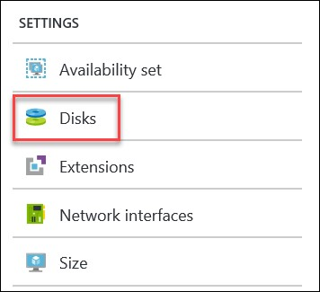

1. Click **Attach new**.



1. Specify the following settings
   * Name: **WebVM-1-DataDisk1**
   * Type: **HDD**
   * Host caching: **Read/Write**.
   * Location: Choose the storage account in the **opsvmrmrg** Resource Group and choose the **vhds** container (Click **Select** and then **OK**)

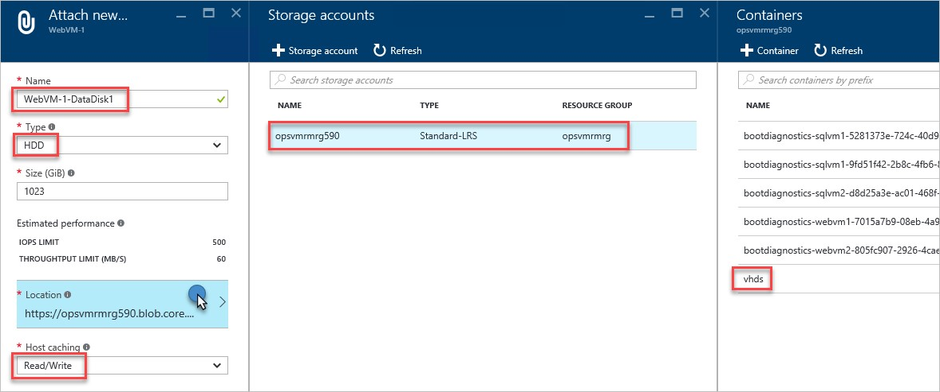

1. Repeat the process and name the second disk **WebVM-1-DataDisk2**.

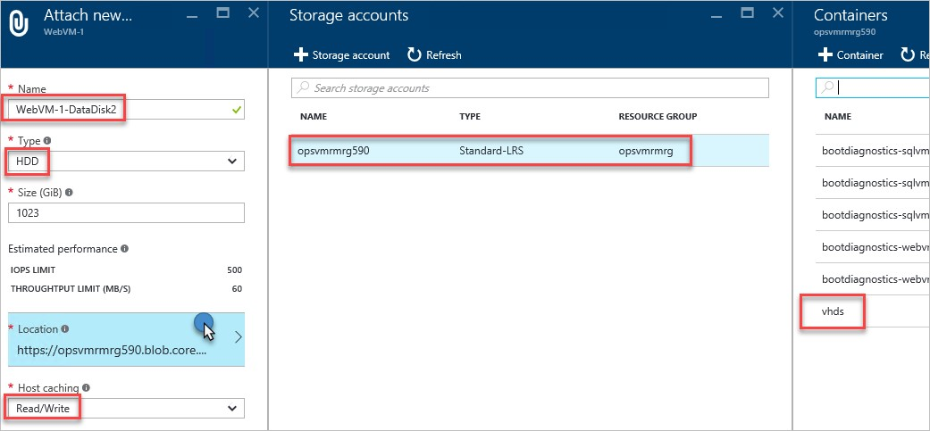

1. Your disk configuration should look similar to the following:

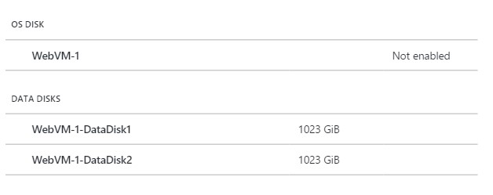

### Exercise 2: Create a new Storage Space for the disks

1. Click the **Connect** button on the toolbar for the **WebVM-1** virtual to connect to it. When prompted use the following credentials:
   * Login: **demouser**
   * Password: **demo@pass123**

1. Inside the virtual machine click Windows Server Manager.



1. Click **File and Storage Services** from within Windows Server Manager.

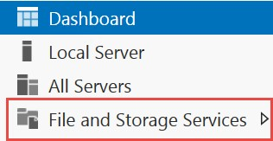

1. Click Storage Pools.

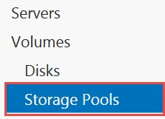

1. Right click on the **Primordial** disks column, and click **New Storage Pool**.

6.

Click

**Next**

on the before you begin step.

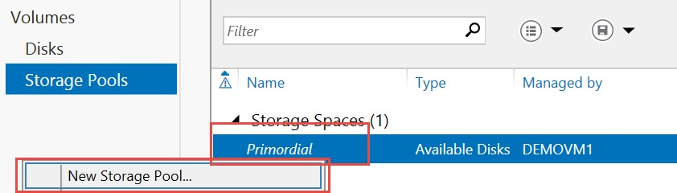

1. Specify the name **StorageSpaceDemo** and click **Next**.

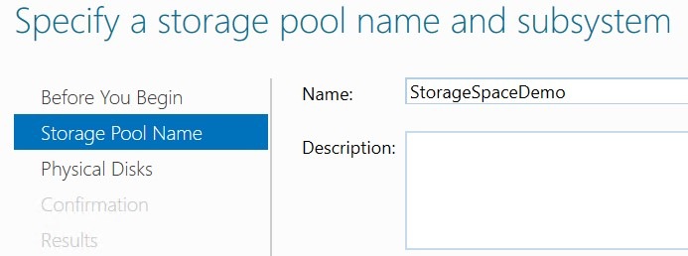

1. Select both disks and click **Next**.

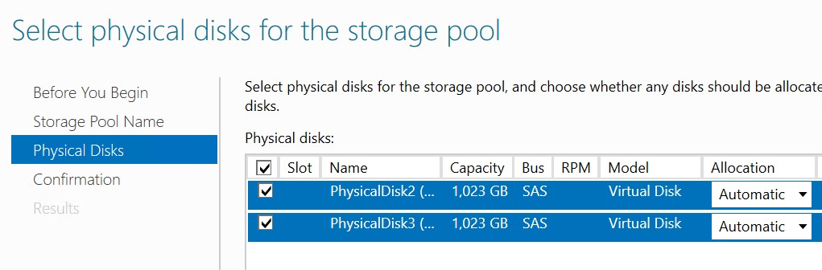

1. Click **Create** on the confirmation step and then **Close** after the storage space is created.

1. Right click on the new **Storage Space**, and click **New Virtual Disk**.

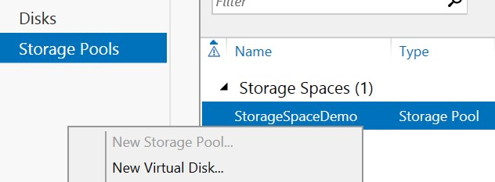

1. Click **Next** on the Before You Begin dialog, and the select the **Storage Pool** created earlier.

1. Name the disk **AzureDisk** and click **Next**.

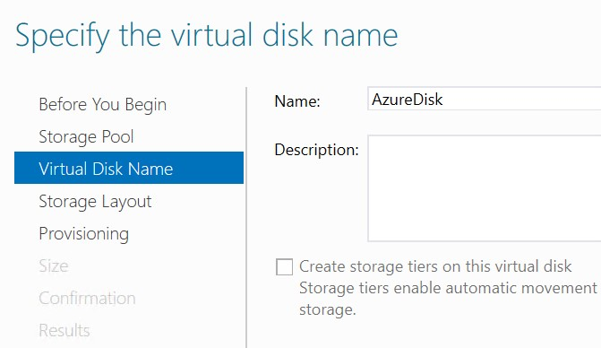

1. For Storage Layout select **Simple**, and then click **Next**.

14.

Accept the default of fixed

.

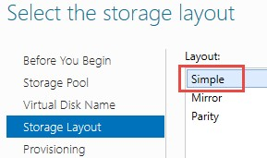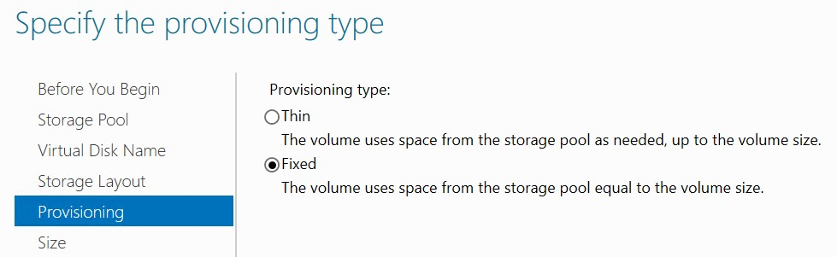

* 1. Change the Size to Maximum size.

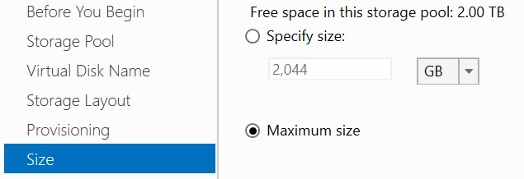

* 1. Click **Create** on the confirm dialog and Complete the New Volume Wizard by accepting the default settings for all dialogs. Note: if the default drive letter is E, change it to **F**.

* 1. At the end of the lab you should have a new 2 TB volume spread across two disks.

18.

Disconnect from Remote Desktop Session.

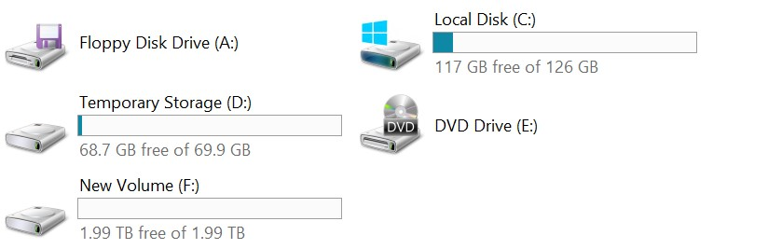

### Exercise 3: Using the Azure Storage Explorer Utility to Copy Disks

1. From **LABVM** download and install Microsoft’s Azure Storage Explorer from http://storageexplorer.com/.

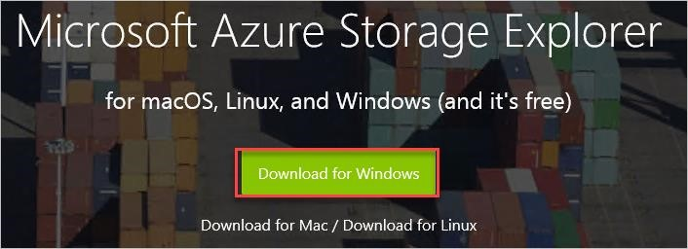

1. After the application starts, click the User icon to configure access to your Azure subscription.

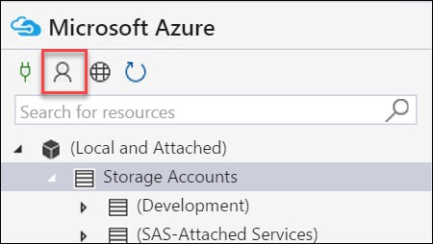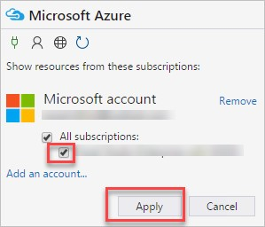

1. Add your account by logging in with the credentials for your Azure Subscription.

If you have multiple subscriptions associated with your Microsoft account, you will be able to filter them out to the subscription you are using for the lab.

1. Double click the storage account used by the virtual machines in earlier labs.

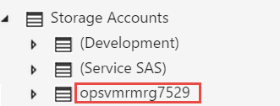

1. Expand **Blob Containers**. You should see the containers for the boot diagnostics screenshots of your virtual machines, and the vhds container. This is the default location where the virtual hard disk (VHD) files for your virtual machines are stored.

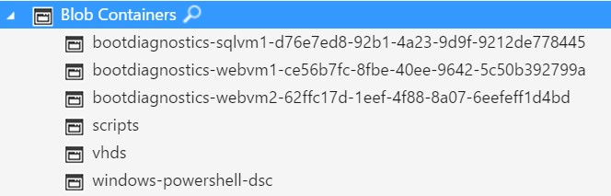

1. Right click on the Blob Containers node and click **Create Blob Container**.

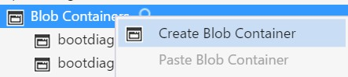

1. Name the new container **diskcopies**.



1. Double-click on the **vhds** container to see its contents and then **sort** by Blob Type until Page Blob is first, **select** all of the Page Blob items, **right click** and click **Copy**.

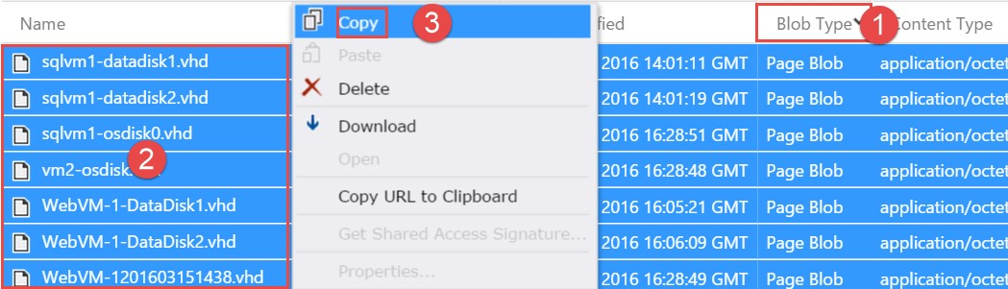

1. Double-click the diskcopies container, after it opens click **Paste** from the toolbar.

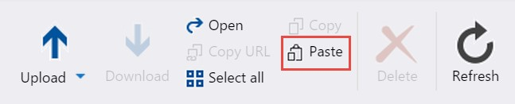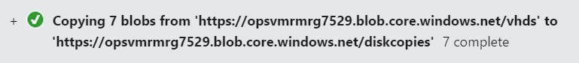

Tip: This tool can be used to copy files to different storage accounts even in remote regions.

### Exercise 4: Using the Storage Explorer Utility to Upload a Disk

1. Within the Storage Explorer Utility, open the **vhds** container of the storage account for your virtual machine.



2.

Click the

**Upload**

button from the toolbar.

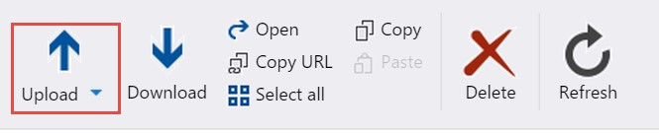

1. Click the Upload Files menu item.

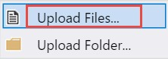

1. In the Upload files dialog, browse to **C:\OpsgilityTraining\DataDisk.vhd** and click **Upload**.

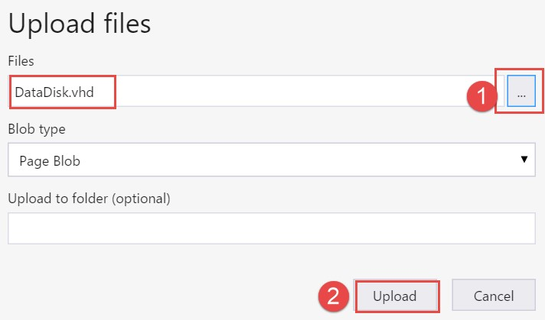

1. Switch back to the Azure Management Portal and open the WebVM-2 virtual machine configuration by clicking **Browse**, **Virtual Machines**, and **WebVM-2.**

1. Click **Disks.**



1. Click **Attach Existing.**



1. Browse to the storage account you uploaded the DataDisk.vhd file to, open the VHDs container, and select the **DataDisk.vhd** file, click the Select button at the bottom of the blade, and then click OK to attach it has a data disk.

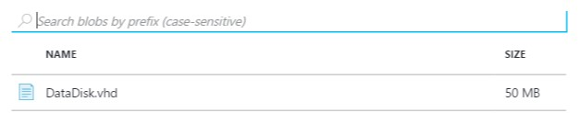

1. Login to the **WebVM-2** virtual machine by clicking the **Connect** button on the toolbar of the virtual machine.

1. From within the virtual machine click the File Explorer icon.



1. Navigate to the F: drive (may be E:) and note the disk is attached with data loaded from the uploaded VHD.

Exercise 5: Viewing Diagnostics Data

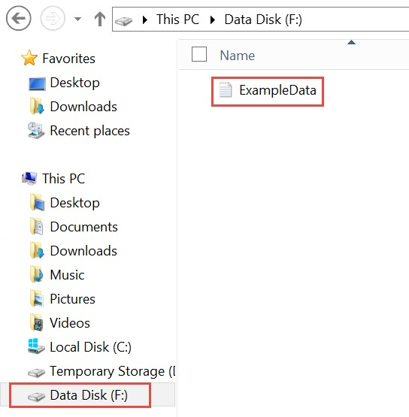

1. The Cerebrata Azure Management Studio (AMS) application can be used to analyze diagnostics data stored in Azure Storage (among other things). From **LABVM** Download and install a trial version of the application here: http://www.cerebrata.com/.

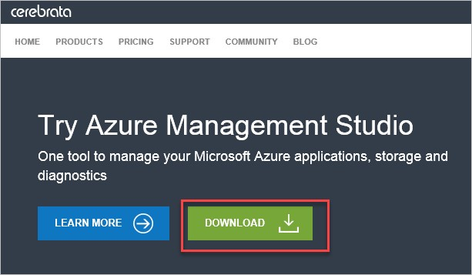

1. The AMS application requires the storage account name and the storage account key. Copy the key by launching the Azure Management Portal, click **Browse**, **Storage Accounts**, and click the storage account with ‘diag’ in the name, such as ‘opsvmrmrgdiag655’ for example.

1. On the Storage Account blade, note the **storage account name**, and click the **Access keys** tile.

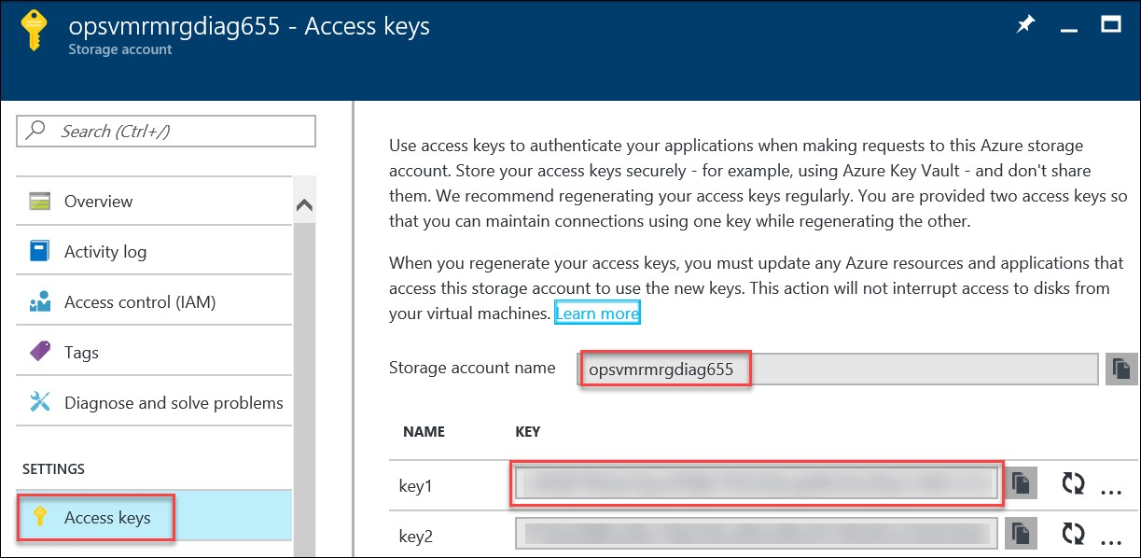

1. Copy the value for **KEY1**.

1. Within the AMS application, click **Add Storage Account Connection.**

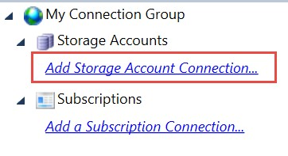

1. Click **Add a Windows Azure Storage account.**

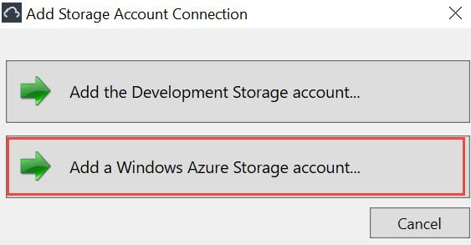

1. Add the **Storage Account name**, and the **Storage Account Key** to the dialog and click **OK**.

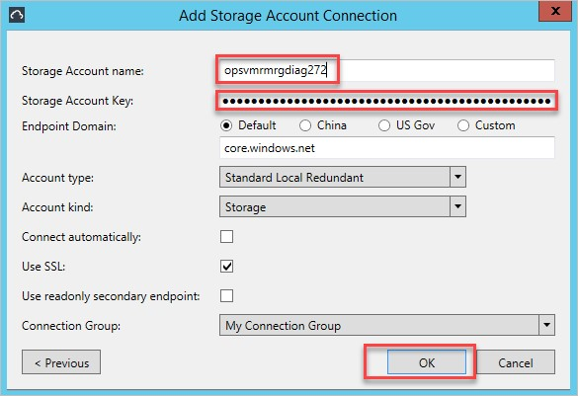

1. Expand the storage account, expand tables and Blob Containers. This is the location of the raw data stored for Azure Diagnostics. The WADWindowsEventLogsTable can be queried to view the event logs from the VM. The WADMetrics* tables contain the captured performance counters in their raw form. The wad-iis-logfiles container (under Blob Containers) stores the IIS

log files, and if configured through the XML configuration additional log files could be captured and stored in blob storage as well.

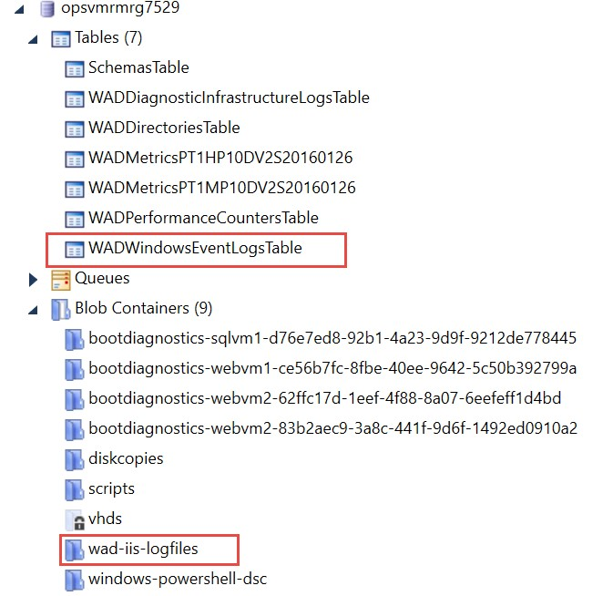

1. After the next synchronization (within an hour) you will see a new container created named **wad-iis-logfiles**.

Note: If the log files are not synchronized yet, you can revisit this step later.

1. If configured through XML you can capture Crash Dumps, and IIS Failed Request Logs. In this example you should be able to view the IIS Logs and Performance counters.

L

ab

Summary

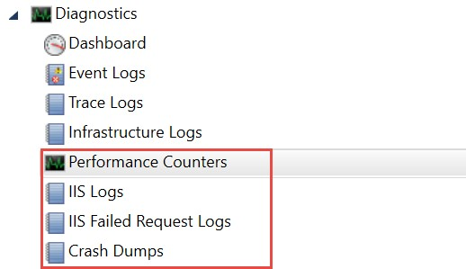

In this lab, you learned how to attach additional storage from the Azure Management Portal and manage the underlying storage using Azure Storage Explorer.